void main() {

List<int> numbers = [5, 10, 15, 20, 25];

numbers.add(30);

numbers.removeAt(0);

List<int> greaterThan15 = numbers.where((number) => number > 15).toList();

List<int> multipliedNumbers = numbers.map((number) => number \* 2).toList();

print("Numbers greater than 15: $greaterThan15");

print("Multiplied numbers: $multipliedNumbers");

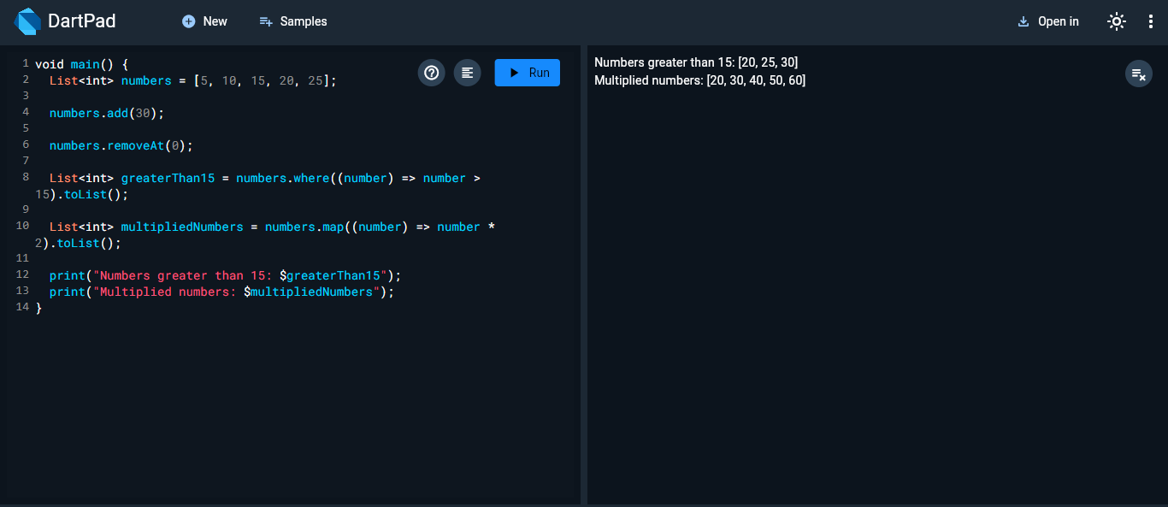

void main() {

  Set<int> set1 = {1, 2, 3, 4, 5};

  Set<int> set2 = {3, 4, 5, 6, 7};

  Set<int> unionSet = set1.union(set2);

  Set<int> intersectionSet = set1.intersection(set2);

  Set<int> differenceSet = set1.difference(set2);

  print("Union: $unionSet");

  print("Intersection: $intersectionSet");

  print("Difference: $differenceSet");

}

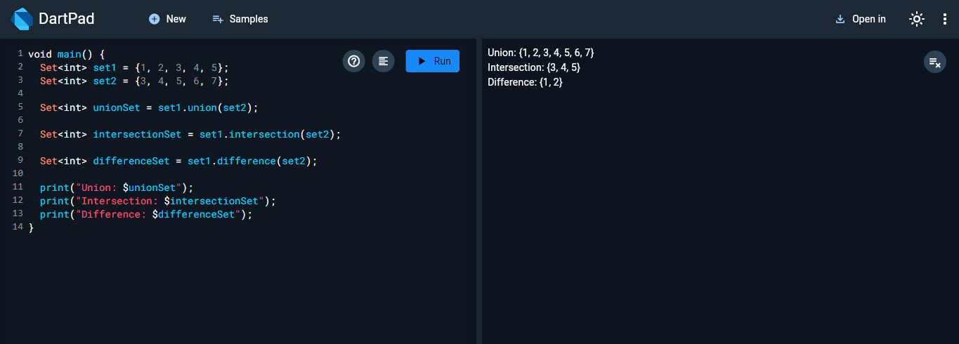

void main() {

Map<String, int> products = {

"Laptop": 1500,

"Phone": 800,

"Tablet": 400,

};

products["Smartwatch"] = 200;

products["Phone"] = 850;

products.remove("Tablet");

List<String> expensiveProducts = products.keys.where((product) => products[product]! > 500).toList();

print("Expensive products: $expensiveProducts");

}

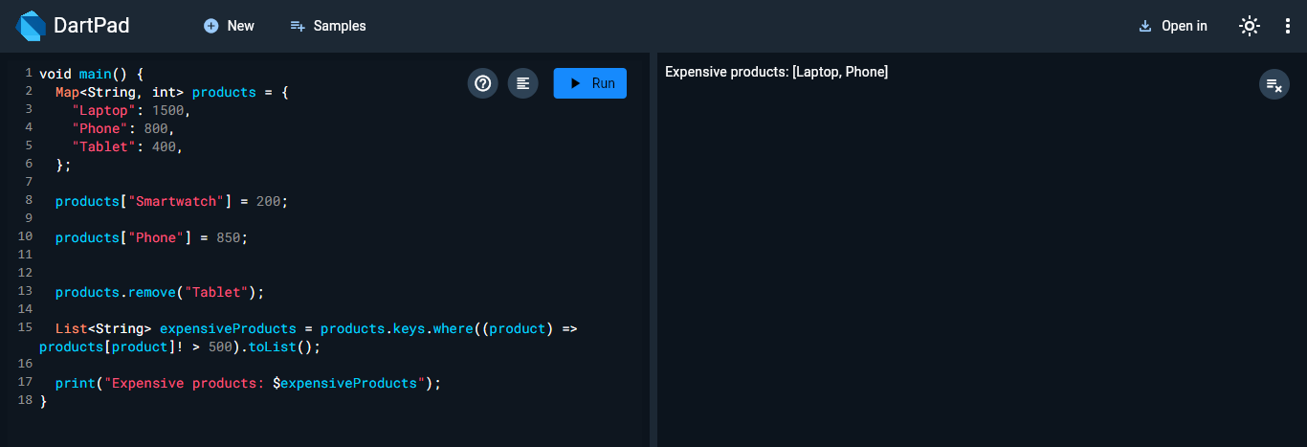

void main() {

  String? name = null;

  name ??= "Guest";

  print("Name: $name");

}

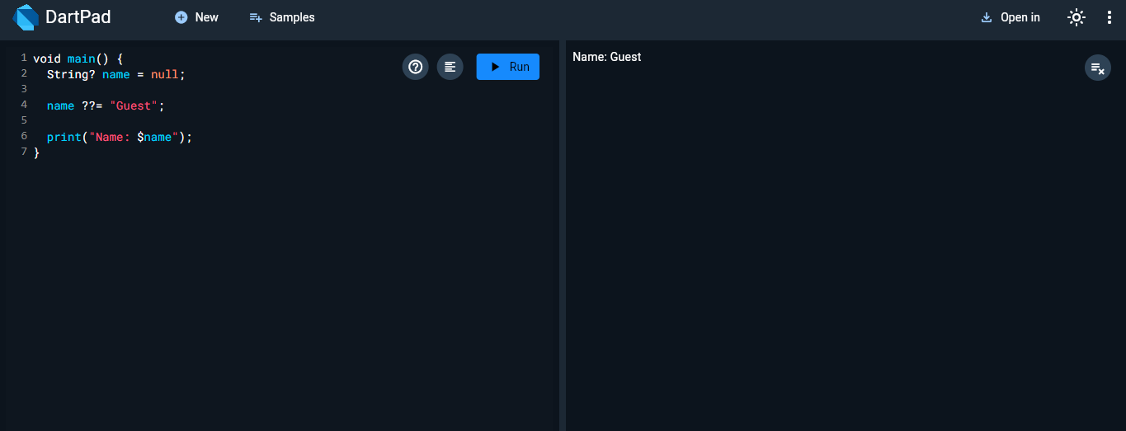

void main() {

  List<int?> numbers = [1, null, 2, null, 3];

  List<int> nonNullNumbers = numbers.whereType<int>().toList();

  print("Updated list: $nonNullNumbers");

}

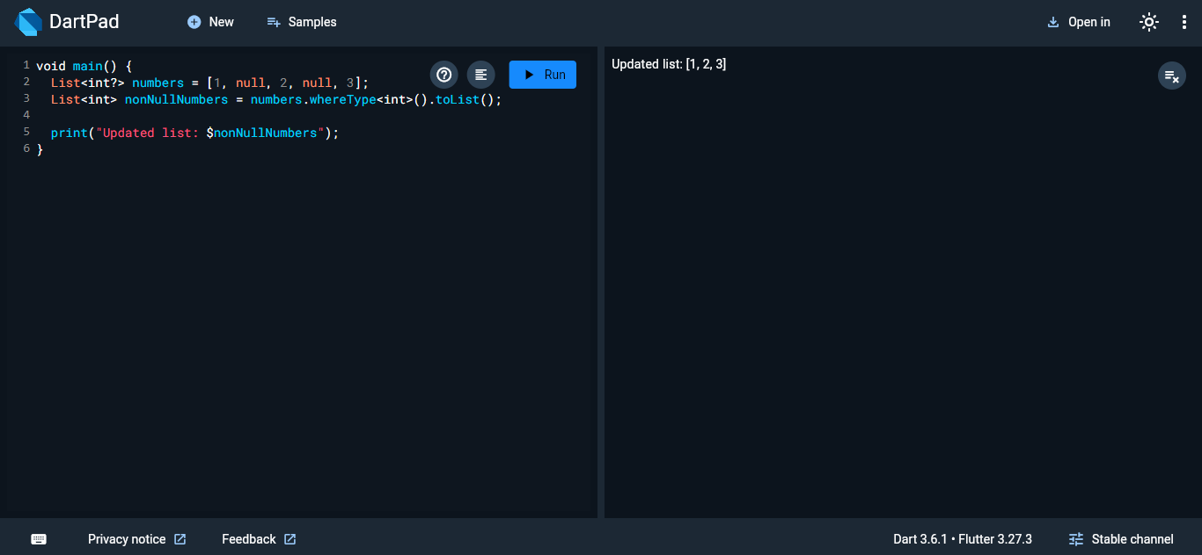

void main() {

  int? value = null;

  value ??= 100;

  print("Value: $value");

}

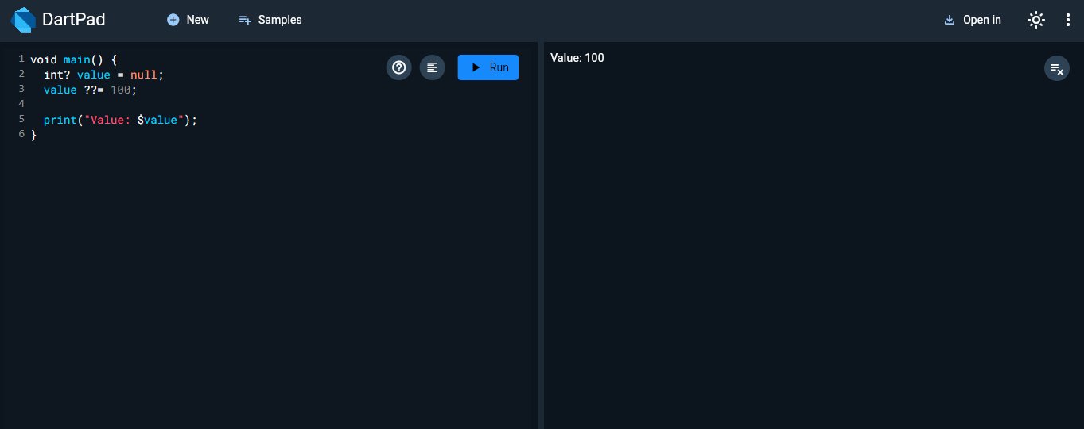

void main() {

  int x = 10;

  if (x > 0) {

    print("$x is positive");

  } else if (x < 0) {

    print("$x is negative");

  } else {

    print("$x is zero");

  }

}

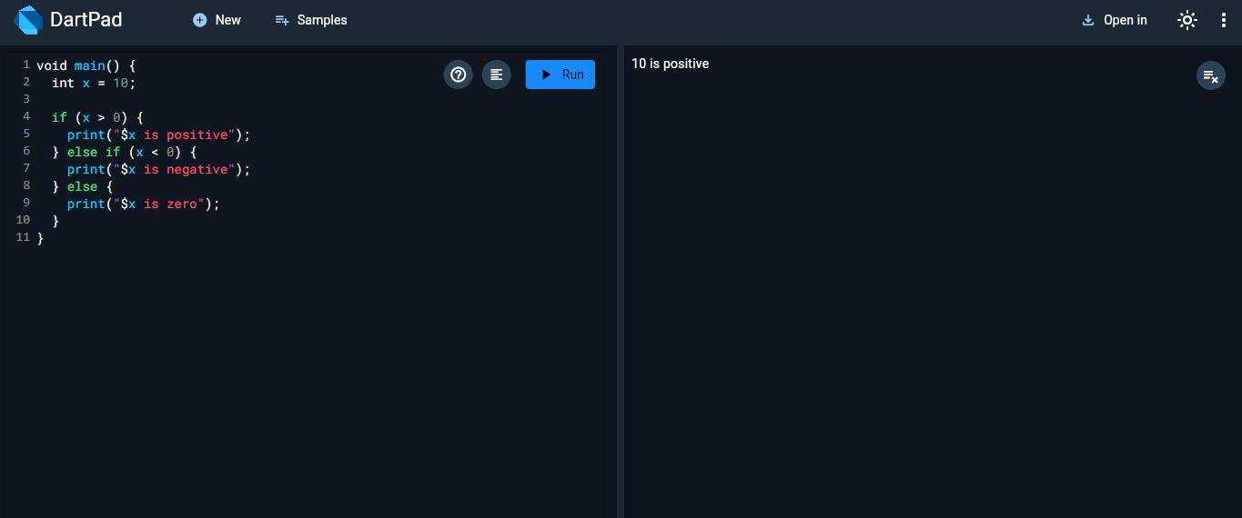

void main() {

  String role = "editor";

  switch (role) {

    case "admin":

      print("Admin Access");

      break;

    case "editor":

      print("Editor Access");

      break;

    case "viewer":

      print("Viewer Access");

      break;

    default:

      print("No Access");

  }

}

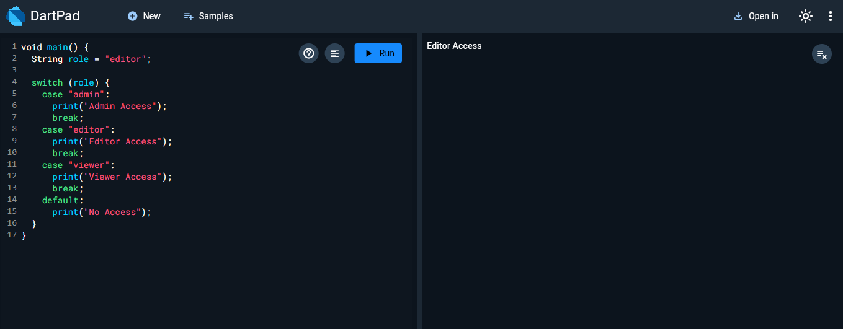

void main() {

  List<int> numbers = [1, 2, 3, 4, 5];

  for (int number in numbers) {

    print("Square of $number is ${number \* number}");

  }

}

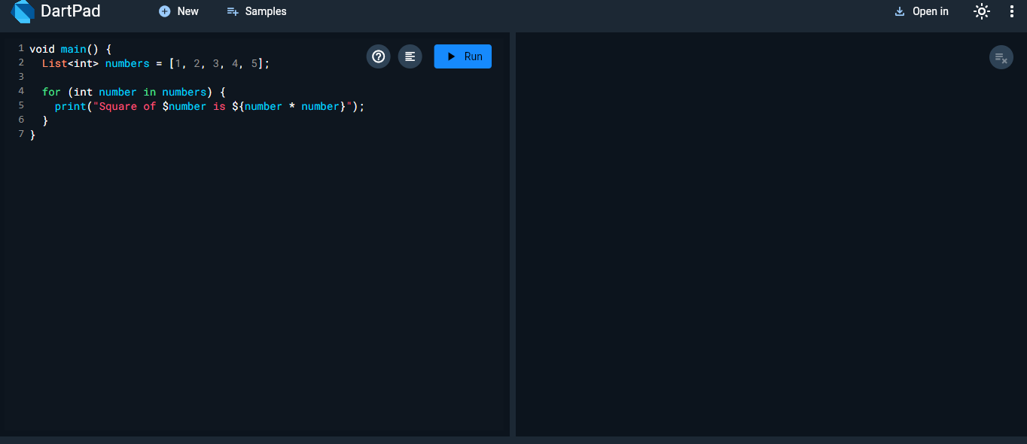

void main() {

  int i = 10;

  while (i >= 1) {

    print(i);

    i--;

  }

}

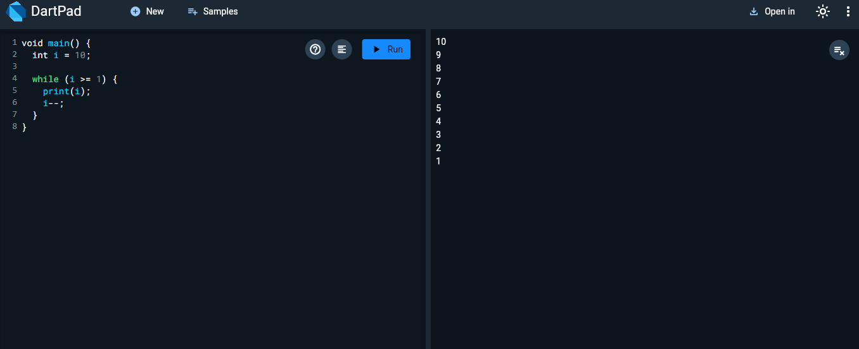

void main() {

  int i = 1;

  do {

    print(i);

    i++;

  } while (i <= 5);

}

